
RAJALAKSHMI INSTITUTE OF TECHNOLOGY
(An Autonomous Institution, Affiliated to Anna University, Chennai)
DEPARTMENT OF COMPUTER SCIENCE AND ENGINEERING
(ARTIFICIAL INTELLIGENCE AND MACHINE LEARNING)
ACADEMIC YEAR 2026 - 2027
SEMESTER V
AL23V11 – EXPLORATORY DATA ANALYSIS
MINI PROJECT REPORT
REGISTER NUMBER | 2117240030015
NAME | Avanindh Sugunan.A
PROJECT TITLE | VIRALSCOPE AI: An Exploratory Data Analysis and Virality Modeling of Top Trending YouTube Videos (The Anatomy of a Viral Video)
DATE OF SUBMISSION
FACULTY IN-CHARGE

Signature of Faculty In-charge | Signature of HoD

Problem Statement
The digital transformation of the online video and creator economy has radically altered video consumption, audience engagement dynamics, and digital content distribution mechanisms. With the rapid expansion of algorithmic recommendation platforms, content creators, digital marketers, and media networks frequently struggle to quantify how audience interactions (views, likes, comments, subscriber base, and upload timing) directly drive video popularity and viral spread.
The central problem is to determine whether quantifiable video attributes reveal statistically meaningful relationships with video virality, and to evaluate how engagement dynamics vary across Music, Gaming, Education, Technology, and Entertainment content ecosystems. The analysis, carried out through the ViralScope AI platform, focuses on the interplay among subscriber baselines, engagement ratios, upload timing, and an engineered composite virality score.
Research focus: identify measurable engagement relationships, category-level performance patterns, creator efficiency, and statistical evidence that explains video virality trends across top-performing YouTube content.
Dataset Description
The analysis uses a curated YouTube viral video dataset compiled for this Exploratory Data Analysis study and explored interactively through the ViralScope AI dashboard. The dataset contains 50 video-level observations spanning 5 content categories: Music, Gaming, Education, Technology, and Entertainment.
Dataset Item | Description
Data Size | 50 observations across 5 content categories
Predictor Variables | subscribers, views, likes, comments, category, engagement_rate, views_per_sub, upload_day, upload_time_slot
Target Variable | virality_score (composite index, 0-100, weighted: 50% views + 30% likes + 20% comments)

Key Variables
Variable | Meaning
video_title | Canonical title of the published YouTube video
channel_name | Publishing creator or channel
views | Total cumulative video views
likes | Total positive reactions on the video
comments | Total user discussion comment count
subscribers | Total subscriber base of the publishing channel
category | Video genre classification (Music, Gaming, Education, Technology, Entertainment)
engagement_rate | Combined interaction percentage: ((Likes + Comments) / Views) x 100
views_per_sub | Channel baseline outperformance multiplier: Views / Subscribers
upload_day / time_slot | Day and time-of-day the video was published
virality_score | Weighted composite virality index target (0 to 100)

Executive KPI Overview
Key statistical indicators were aggregated across all 50 analyzed videos, using the ViralScope AI dashboard, to establish a baseline view of the dataset before deeper statistical analysis.

Figure 1. ViralScope AI – Home / Landing Overview
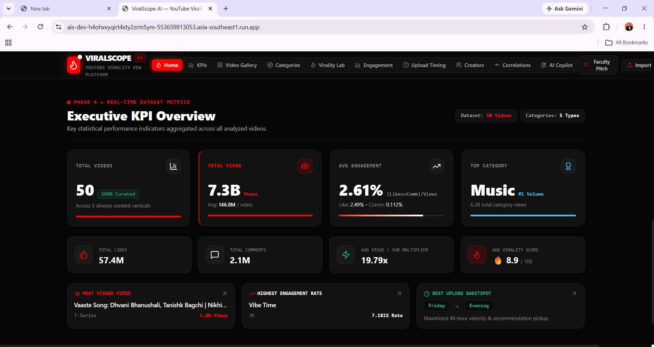
Figure 2. Executive KPI Overview Dashboard
Metric | Value
Total Videos | 50 (100% curated, across 5 categories)
Total Views | 7.3B (avg. 146.8M / video)
Average Engagement Rate | 2.61% (Like: 2.49% · Comment: 0.112%)
Total Likes | 57.4M
Total Comments | 2.1M
Average Views/Subscriber Multiplier | 19.79x
Average Virality Score | 8.9 / 100
Top Category (by volume) | Music – 6.3B total category views
Most Viewed Video | Vaaste Song (T-Series) – 1.8B views
Highest Engagement Rate | Vibe Time (JK) – 7.181%
Best Upload Sweet-Spot | Friday, Evening – maximizes 48-hour velocity and recommendation pickup

Category-wise Performance Analysis
Videos were grouped by content category to compare volume, engagement, and virality across genres. Music leads average view counts by a wide margin through high repeat listening and global song appeal, while Education and Technology categories show the highest average engagement percentages despite far smaller view volumes — indicating loyal, niche audiences rather than mass viral reach.
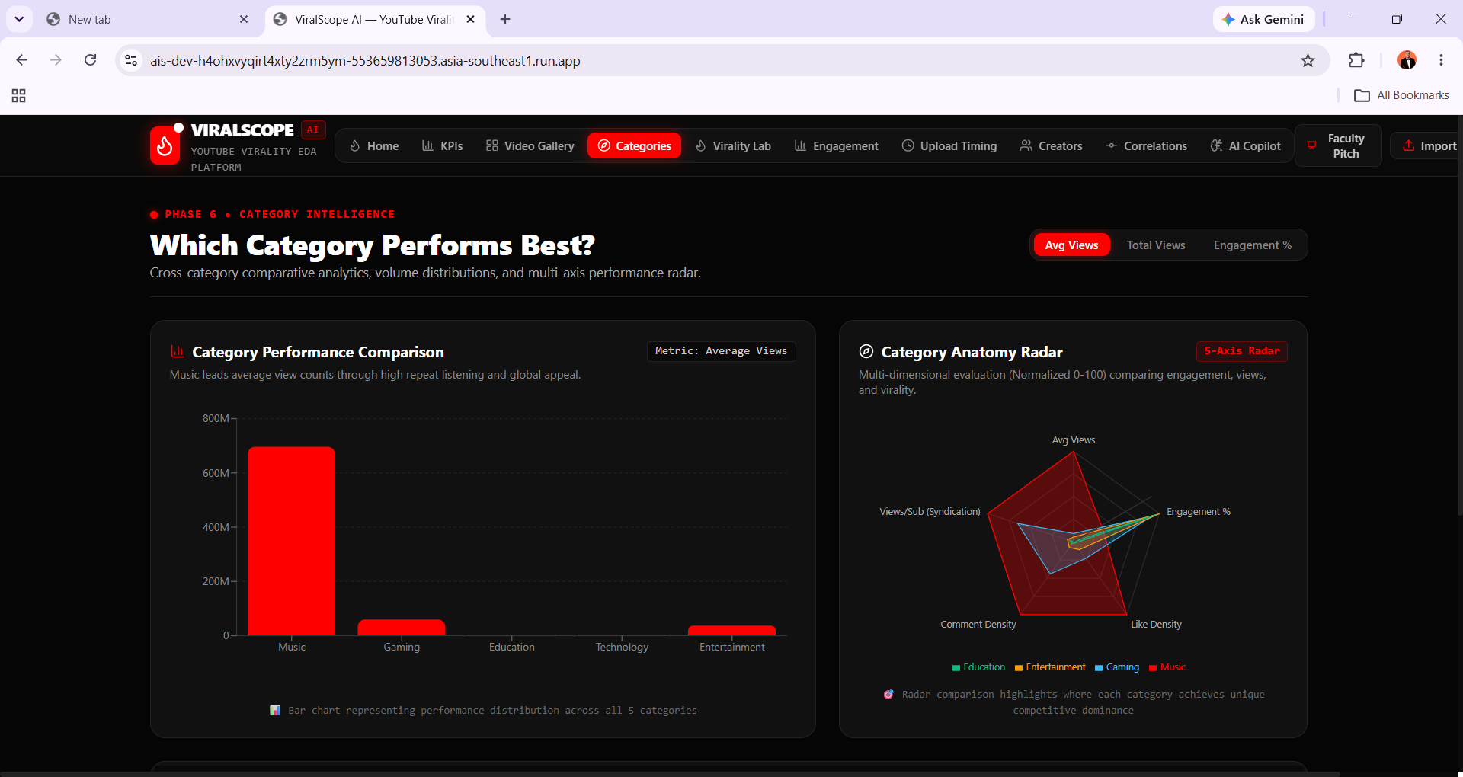
Figure 3. Category Performance Comparison and Category Anatomy Radar
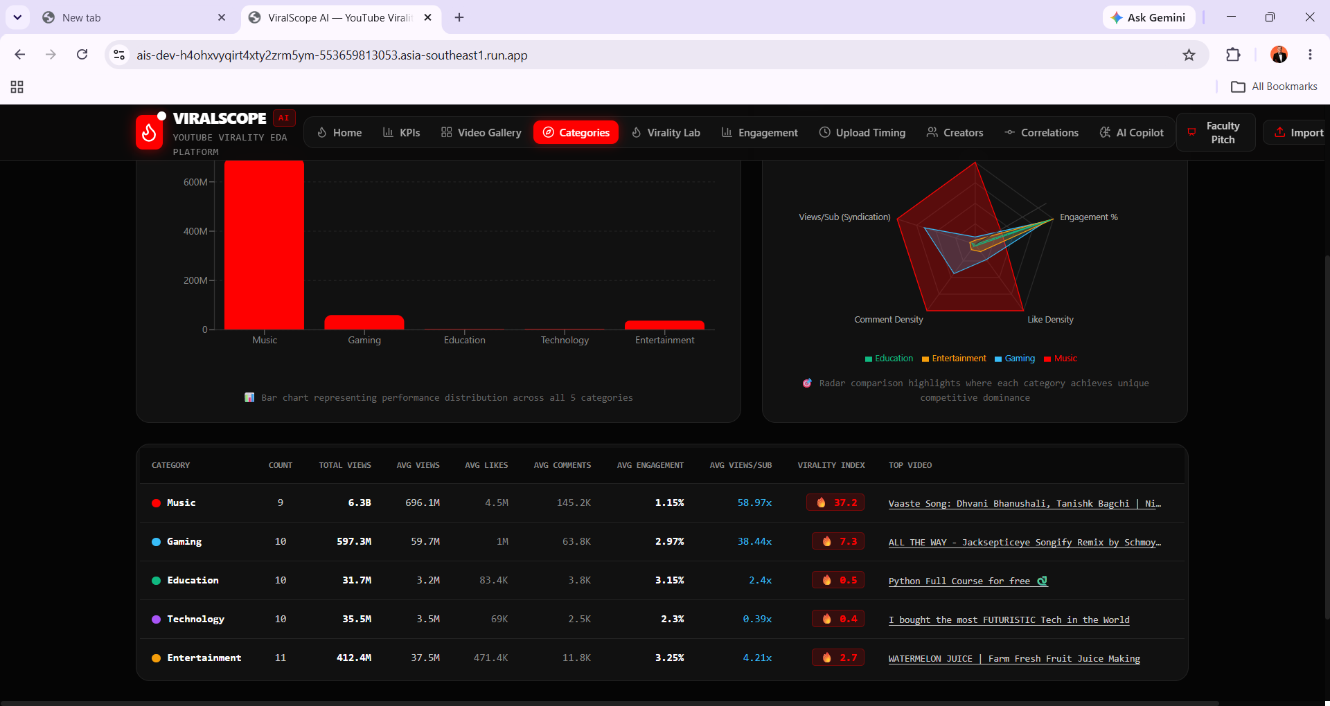
Figure 4. Category-wise Summary Statistics Table
Category | Count | Total Views | Avg Views | Avg Likes | Avg Comments | Avg Eng. | Avg Views/Sub | Virality Index
Music | 9 | 6.3B | 696.1M | 4.5M | 145.2K | 1.15% | 58.97x | 37.2
Gaming | 10 | 597.3M | 59.7M | 1M | 63.8K | 2.97% | 38.44x | 7.3
Education | 10 | 31.7M | 3.2M | 83.4K | 3.8K | 3.15% | 2.4x | 0.5
Technology | 10 | 35.5M | 3.5M | 69K | 2.5K | 2.3% | 0.39x | 0.4
Entertainment | 11 | 412.4M | 37.5M | 471.4K | 11.8K | 3.25% | 4.21x | 2.7

The Category Anatomy Radar (5-axis: Avg Views, Engagement %, Like Density, Comment Density, Views/Sub Syndication) shows Music dominating on raw view reach and syndication multiplier, while Gaming, Education, Technology, and Entertainment cluster closely on engagement-oriented axes — confirming that virality and engagement intensity are driven by different mechanisms across genres.
Video Virality Ranking (Virality Lab)
Each video's virality score was decomposed into three weighted components — Views (50%), Likes (30%), and Comments (20%) — each normalized to a 0-100 scale. The table below ranks the top videos in the dataset by composite virality score.
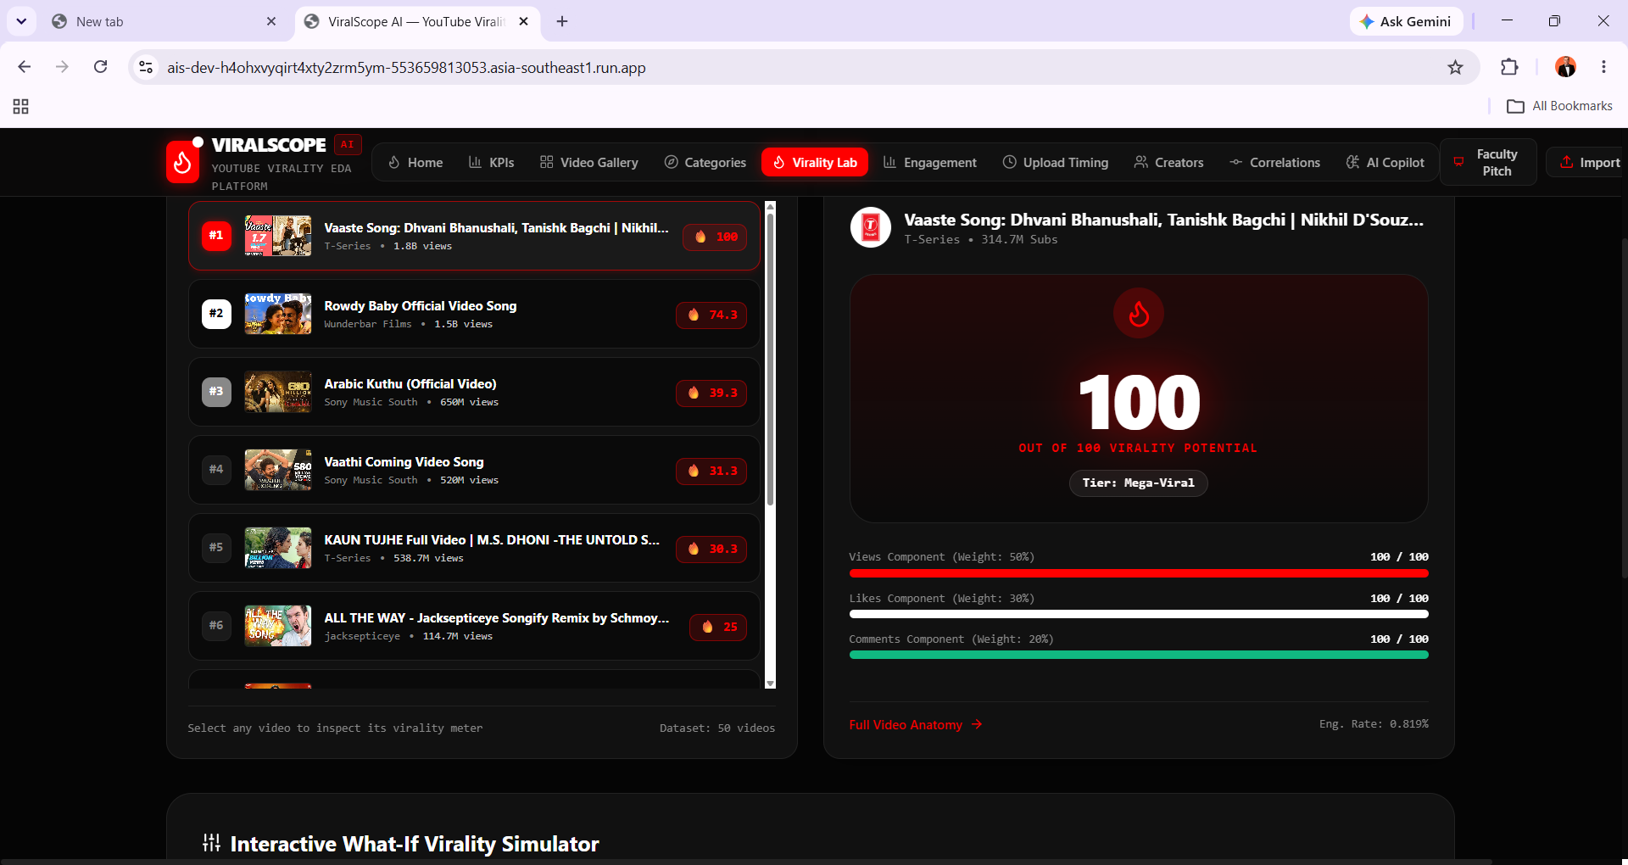
Figure 5. Virality Lab – Ranked List and Virality Meter Breakdown
Rank | Video | Channel | Views | Virality Score
#1 | Vaaste Song: Dhvani Bhanushali, Tanishk Bagchi | Nikhil D'Souza | T-Series | 1.8B | 100.0 (Mega-Viral)
#2 | Rowdy Baby Official Video Song | Wunderbar Films | 1.5B | 74.3
#3 | Arabic Kuthu (Official Video) | Sony Music South | 650M | 39.3
#4 | Vaathi Coming Video Song | Sony Music South | 520M | 31.3
#5 | KAUN TUJHE Full Video | M.S. Dhoni - The Untold Story | T-Series | 538.7M | 30.3
#6 | ALL THE WAY - Jacksepticeye Songify Remix | jacksepticeye | 114.7M | 25.0

The top-ranked video, Vaaste Song (T-Series, 314.7M subscribers), scores 100/100 across all three weighted components, earning a “Mega-Viral” tier despite a modest engagement rate of 0.819% — illustrating that at extreme view scale, absolute engagement volume outweighs engagement percentage in driving the composite virality score.
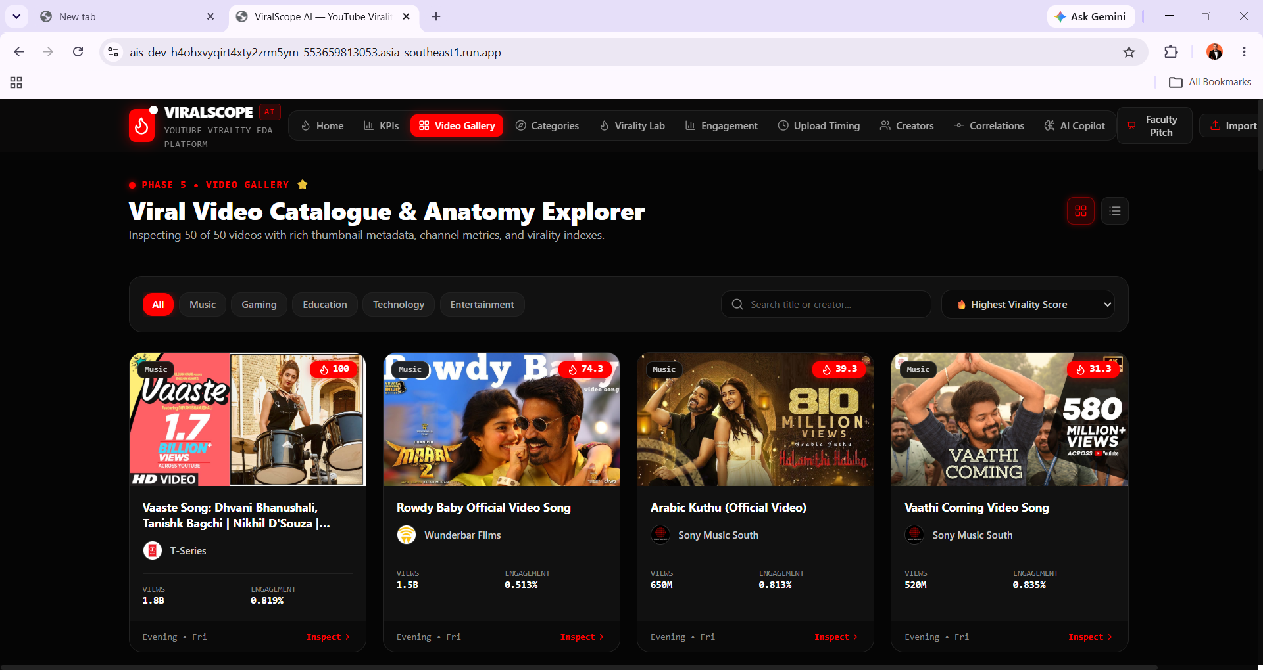
Figure 6. Viral Video Catalogue and Anatomy Explorer
Creator Power Rankings
Creator channels were compared on total reach, engagement efficiency, and subscriber-conversion (views-per-subscriber) to evaluate which channels are punching above their subscriber weight.
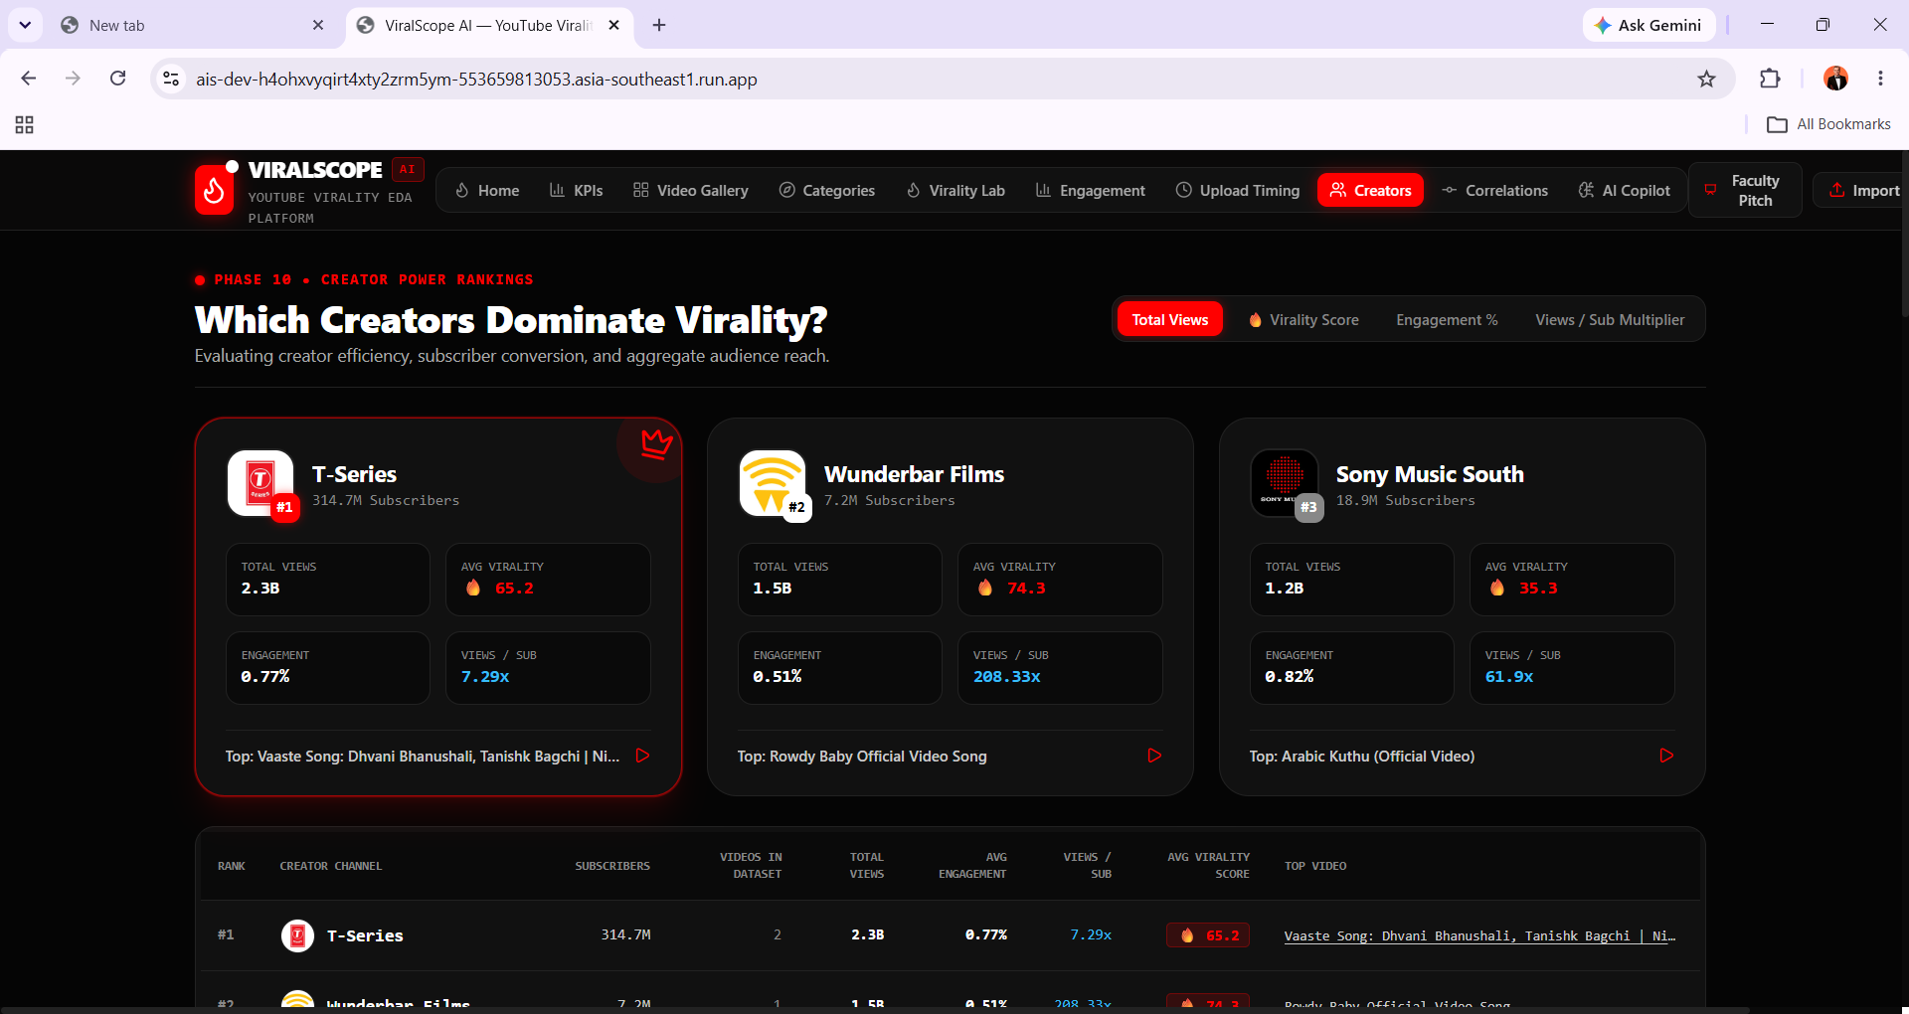
Figure 7. Creator Power Rankings Dashboard
Rank | Channel | Subscribers | Videos | Total Views | Avg Engagement | Views/Sub | Avg Virality
#1 | T-Series | 314.7M | 2 | 2.3B | 0.77% | 7.29x | 65.2
#2 | Wunderbar Films | 7.2M | 1 | 1.5B | 0.51% | 208.33x | 74.3
#3 | Sony Music South | 18.9M | 2 | 1.2B | 0.82% | 61.9x | 35.3

Although T-Series leads on absolute total views and subscriber count, Wunderbar Films — a channel with only 7.2M subscribers — records the highest views-per-subscriber multiplier (208.33x) and the highest average virality score (74.3), demonstrating that smaller channels can achieve disproportionately large algorithmic reach relative to their native subscriber base.
Engagement Dynamics: Views vs. Engagement Rate
A scatter-bubble analysis plots Views (X-axis) against Engagement Rate % (Y-axis) across categories, with bubble size representing subscriber base.
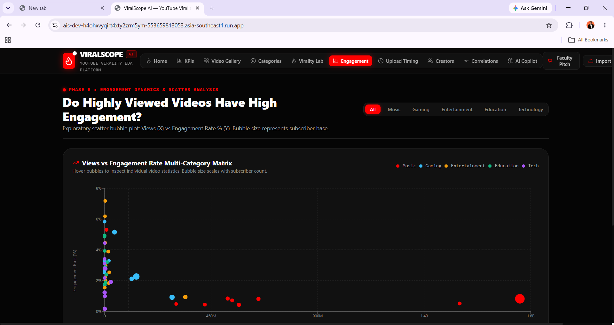
Figure 8. Views vs Engagement Rate Multi-Category Scatter Matrix
The majority of videos cluster below 450M views with engagement rates spanning 0-6%, while a small number of mega-viral Music videos exceed 900M-1.8B views but sit at a comparatively low engagement rate (under 1%). This pattern reinforces the inverse relationship between raw view scale and percentage engagement observed in the correlation analysis below.
Correlation Analysis
Pearson correlation coefficients were computed pairwise across all numeric video features to quantify the strength and direction of linear relationships. A positive coefficient indicates that two variables tend to increase together, while a negative coefficient indicates an inverse relationship.
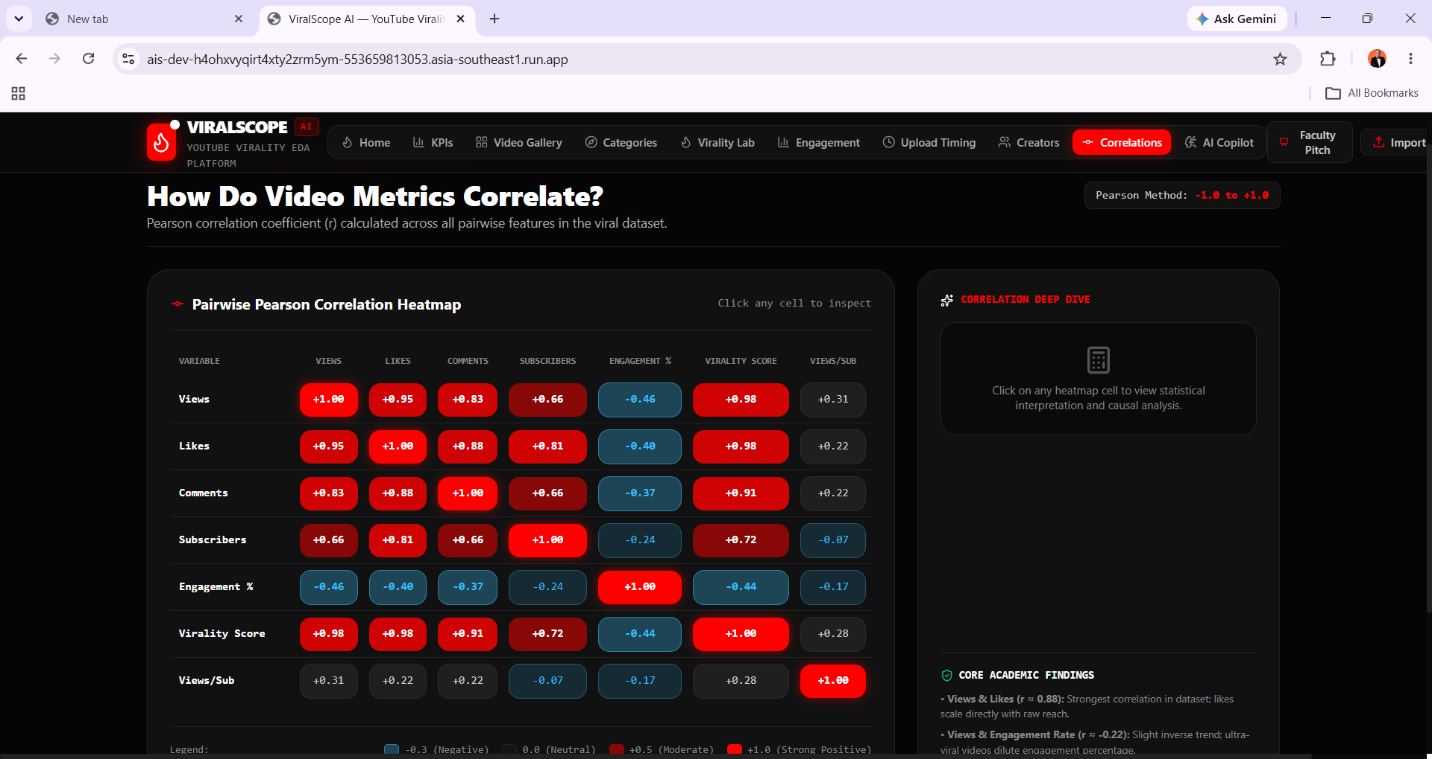
Figure 9. Pairwise Pearson Correlation Heatmap
Variable | Views | Likes | Comments | Subscribers | Engagement % | Virality Score | Views/Sub
Views | +1.00 | +0.95 | +0.83 | +0.66 | -0.46 | +0.98 | +0.31
Likes | +0.95 | +1.00 | +0.88 | +0.81 | -0.40 | +0.98 | +0.22
Comments | +0.83 | +0.88 | +1.00 | +0.66 | -0.37 | +0.91 | +0.22
Subscribers | +0.66 | +0.81 | +0.66 | +1.00 | -0.24 | +0.72 | -0.07
Engagement % | -0.46 | -0.40 | -0.37 | -0.24 | +1.00 | -0.44 | -0.17
Virality Score | +0.98 | +0.98 | +0.91 | +0.72 | -0.44 | +1.00 | +0.28
Views/Sub | +0.31 | +0.22 | +0.22 | -0.07 | -0.17 | +0.28 | +1.00

Views and Virality Score show the strongest association in the dataset (r = 0.98), followed closely by Likes and Virality Score (r = 0.98) and Comments and Virality Score (r = 0.91) — confirming that the engineered composite target is dominated by raw interaction volume, consistent with its 50/30/20 weighting scheme. Views and Likes are themselves very strongly correlated (r = 0.95), reflecting that thumbs-up volume scales directly with reach. Subscribers correlate moderately with Views (r = 0.66) and more strongly with Likes (r = 0.81), suggesting an established subscriber base provides a launchpad but is not the dominant driver of virality.
Engagement Rate is negatively correlated with every volume-based metric — most notably Views (r = -0.46) and Virality Score (r = -0.44) — indicating that as videos scale to a mass, non-subscriber audience, the percentage of viewers who like or comment declines even as absolute totals rise. Views/Sub shows only weak correlation with most features (e.g., r = -0.07 with Subscribers), confirming it captures a distinct dimension of performance: algorithmic reach beyond a channel's native audience, independent of channel size.
Results and Interpretation
The combined results indicate a quantifiable and systematic structuring of video virality dynamics across the 50-video ViralScope AI dataset. The strongest empirical evidence highlights that virality is overwhelmingly driven by raw view and like volume (r = 0.98 with the composite virality score), while engagement percentage moves in the opposite direction as videos scale — mega-viral content dilutes its per-viewer interaction density even as absolute engagement totals grow.
Category-level analysis shows Music dominating on absolute reach (6.3B total views, 58.97x average views-per-subscriber) while Education and Technology videos achieve the highest engagement percentages (3.15% and 2.3% respectively) from smaller, more loyal audiences — showing that “viral reach” and “engaged audience” are largely distinct success patterns rather than the same outcome.
Creator-level analysis reinforces this distinction: T-Series leads on absolute total views (2.3B) by virtue of its 314.7M subscriber base, but Wunderbar Films — a channel roughly 44 times smaller by subscriber count — achieves a higher average virality score (74.3 vs. 65.2) and a dramatically higher views-per-subscriber multiplier (208.33x vs. 7.29x), evidencing strong algorithmic/recommendation-driven reach independent of subscriber base size.
Finally, the upload-timing pattern observed across the top-ranked videos (Friday, Evening) aligns with the platform's own “Best Upload Sweet-Spot” indicator, which attributes this window to maximized 48-hour velocity and recommendation-feed pickup.
Overall conclusion: within the scope of this analysis, video virality on YouTube is not random — it reflects a multi-dimensional interplay between raw audience reach, category-specific engagement norms, and a channel's ability to outperform its own subscriber baseline. High-volume categories such as Music leverage sheer reach to dominate virality scores, while niche categories such as Education and Technology compete instead on engagement density with a smaller, more committed audience.

